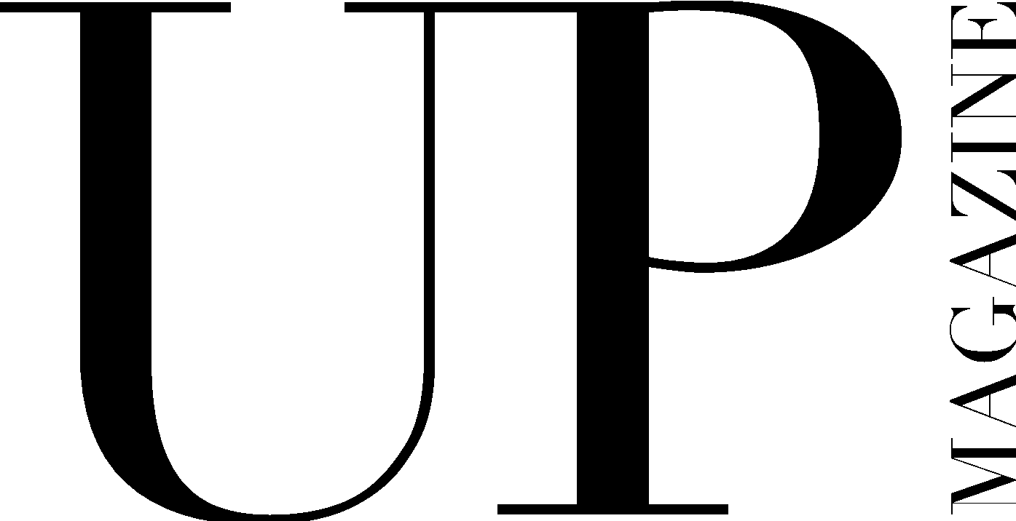

LAYOUT DESIGNER APPLICATION

UP Magazine is Miami University’s student-run fashion and lifestyle publication inspiring style and authenticity. UP Magazine is seeking talented, creative, committed, and driven student designers who are excited to be part of a collaborative and contemporary team.

The Layout Designer of UP Magazine is responsible for combining photographs and stories into print layouts. The Layout Designer must have a strong eye for design in order to create layouts that are both timeless and relate to each unique theme. The Layout Designer is responsible for creating at least one spread in each of the three issues published throughout the year. The Layout Designer will work closely with and report to the Creative Director. This position requires creativity, commitment, and collaboration.

Name:
Email:
Year:
Phone:
Website:
Major(s);
Minor(s):

Current on-campus involvement:

How much time can you commit to this position a week?

Related experience:

Why do you want to be a part of UP Magazine?

What is your design process?

Where do you find design inspiration?

Do you have access to Adobe Creative Cloud?

Do you have experience with Creative Suite, specifically InDesign?

What makes you the ideal candidate for this position?

Please include 2-3 examples of related work either in this application or attached in your email:

Any additional information, questions, concerns, or comments:

