PRINT STYLIST APPLICATION

UP Magazine is Miami University’s student-run fashion and lifestyle publication inspiring style and authenticity. UP Magazine is seeking talented, creative, committed, and driven student stylists who are excited to be part of a collaborative and contemporary team.

The Print Stylist of UP Magazine is responsible for styling at least one photoshoot that will be published in our fall and spring issues. The stylist is responsible for using their own closet, a friend’s closet, or occasionally, the nuuly.com subscription service. The Print Stylist is responsible for working with a Print Photographer to plan the photoshoots location, model(s), and overall mood of the shoot. The Print Stylist will receive creative direction and inspiration for all photoshoots from the Creative Director and the Directors of Fashion.

*Please note that UP offers another styling position as a Digital Stylist. This position is separate from the Print Stylist position, a part of a separate team, and requires a separate application. You may apply for both styling positions. To find more information about what it means to be a Digital Stylist at UP and to apply please locate the Digital Stylist Application.

Name:
Email:
Year:
Phone:
Instagram:
Major(s):
Minor(s):

Are you applying to be a Digital Stylist as well as a Print Stylist?

Current on-campus involvement:

Related Experience:

Why do you want to be a part of UP Magazine?

How much time can you commit to this position a week?

Where do you find style inspiration (provide visual examples)?

Describe your sense of style and provide photos of yourself showing it off below:

MOCK UP STYLING PAGE - MANDATORY PROJECT:
You are given the theme of 2023 Street Style for a page in UP. Please style two full, cohesive outfits below using pieces from nuuly.com, your own closet, or friend’s closets. Please provide images

Here are some inspo pics to get you started:
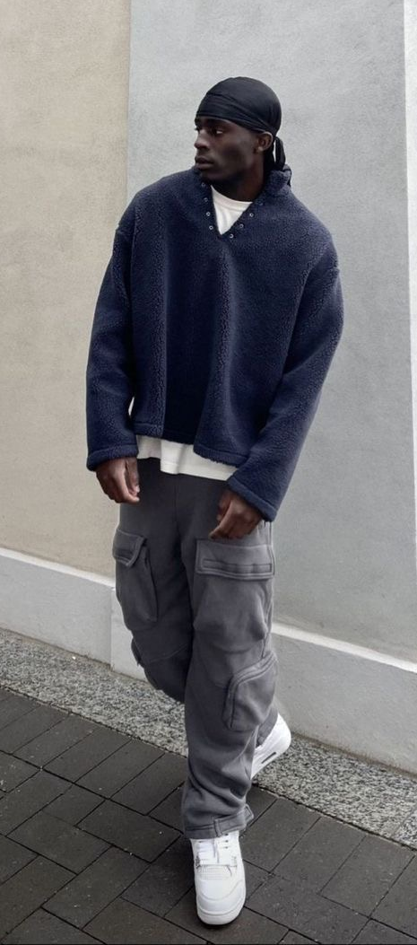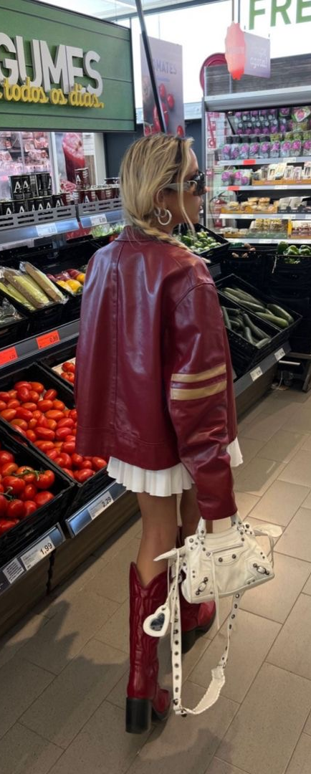

Many of our shoots include male, female and non-binary looks, do you feel confident styling all genders?

Any additional information, questions, concerns, or comments:

