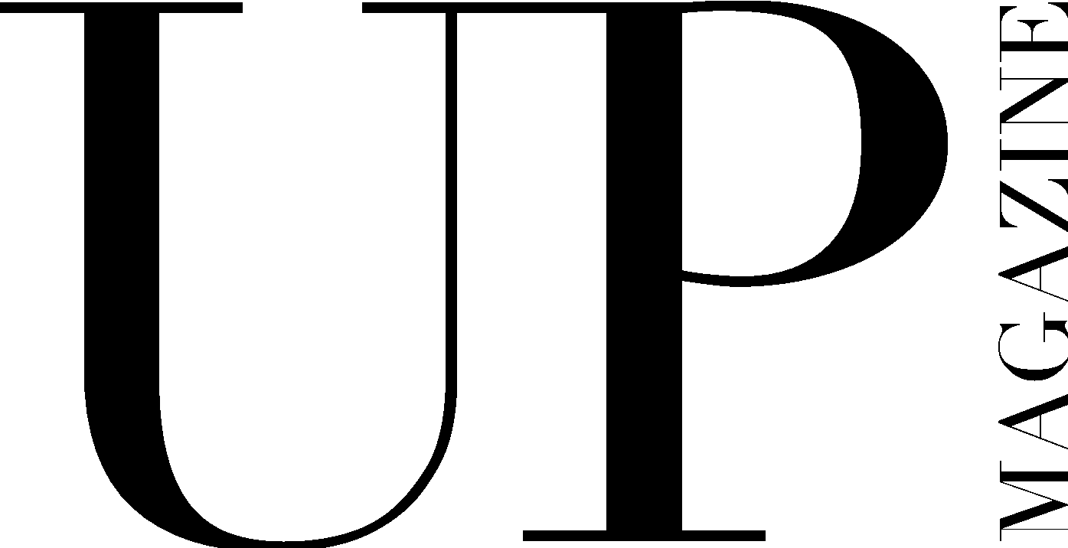

STAFF WRITER APPLICATION

UP Magazine is Miami University’s student-run fashion and lifestyle publication inspiring style and authenticity. UP Magazine is seeking talented, creative, committed, and driven student writers who are excited to be part of a collaborative and contemporary team.

The Staff Writer of UP Magazine is responsible for writing two articles throughout the year for print publication, brainstorming, researching, and conducting in-person or over the phone/Zoom interviews to produce content, attending all-staff meetings, writing team meetings and one-on-one writers conferences with editors.

Name:
Email:
Year:
Phone:
Major(s):
Minor(s):

Current on-campus involvement:

How much time can you commit to this position a week?

Related experience:

Why do you want to be a part of UP Magazine?

What makes you the ideal candidate for this position?

Are you familiar with AP style?

Please include 2-3 examples of related work either in this application or attached in your email.

Attach a link to a fashion/lifestyle article that you have recently read and enjoyed. What did the writer include that you hope to include in your stories for UP?

Brainstorm 1-2 story ideas that fit the UP issue theme of “Influence,” meaning the capacity to have an effect on the character, development, or behavior of someone or something, or the effect itself. Give your story idea(s) a title and include a brief description of the story.

​​Any additional information, questions, concerns, or comments:

