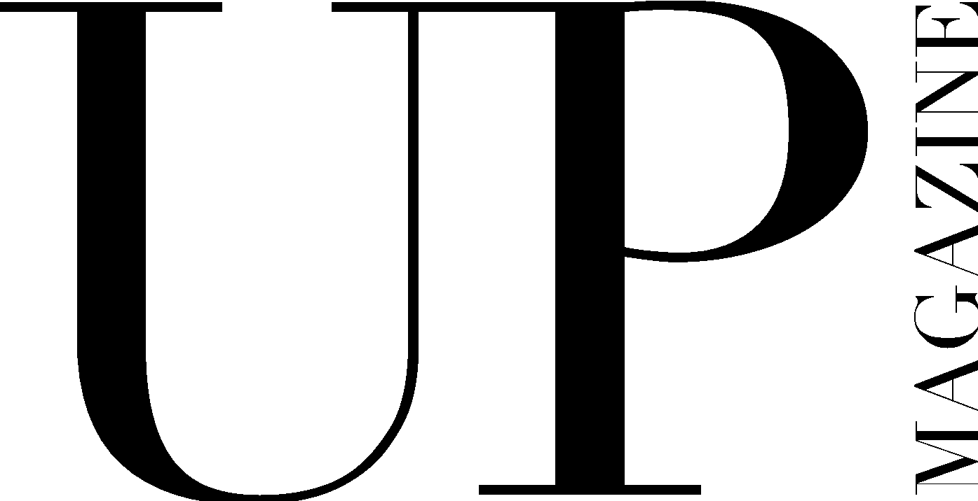

PRINT MAKEUP ARTIST / HAIRSTYLIST APPLICATION

UP Magazine is Miami University’s student-run fashion and lifestyle publication inspiring style and authenticity. UP Magazine is seeking talented, creative, committed, and driven students who are excited to be part of a collaborative and contemporary team.

The Print Makeup Artist / Hairstylist of UP Magazine is responsible for styling makeup / hair for at least one photoshoot that will be published in our fall, winter, and spring issues. The Print Makeup Artist / Hairstylist is responsible for working with a Print Stylist and a Print Photographer to execute the photoshoot. The Print Makeup Artist / Hairstylist will receive creative direction for all photoshoots from the Creative Director and the Director of Fashion.

Name:
Email:
Year:
Phone:
Major(s):
Minor(s):

Will you be in Oxford this fall? If not, will you be back in the Spring?

Current on-campus involvement:

How much time can you commit to this position a week?

Related Experience:

Why do you want to be a part of UP Magazine?

Where do you find makeup/beauty inspiration?

Describe your makeup/beauty style and provide photos below:

