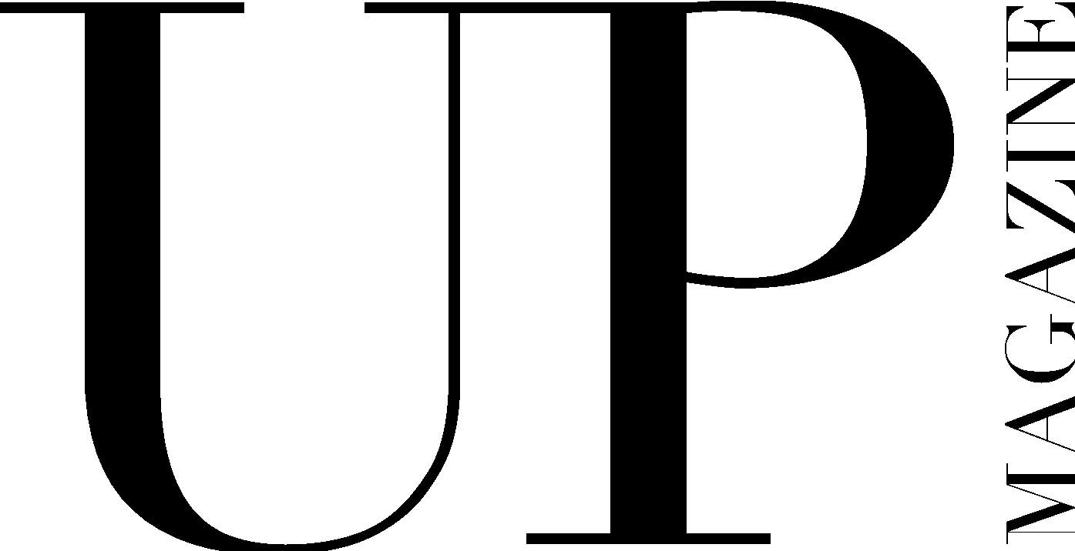

DIRECTOR OF MAKEUP + HAIR APPLICATION

UP Magazine is Miami University’s student-run fashion and lifestyle magazine inspiring style and authenticity. UP Magazine is seeking talented, creative, committed, and driven student writers who are excited to be part of a collaborative and contemporary team.

The Director of Makeup + Hair of UP Magazine is co-director with the Director of Fashion and helps oversee the Styling Team consisting of Print Stylists, Makeup Artists, and Hair Stylists. The Director of Makeup + Hair is responsible for maintaining regular communication with the Styling Team, holding in person meetings, assigning the team to article and editorial photoshoots for each print issue, and supporting and guiding the Print Makeup Artists and Hair Stylists in their creative process. This position requires leadership, commitment, creativity, drive, collaboration, and communication.

Name:
Email:
Year:
Phone:
Major(s):
Minor(s):

Current on-campus involvement:

Years of experience with UP:

Related/relevant experience:

Do you have any past leadership or team management experience?

What makes you the ideal candidate for this position?

Describe your personal style:

If applicable, how has your experience working and styling for UP made you more qualified for the position?

How will you manage the Makeup + Hair Team effectively?

How will you manage and co-direct the entire Styling team with the Director of Fashion?

Describe a stressful situation and how you handled it:

What stressful situations do you anticipate arising from this position and how will you handle those situations?

Where do you find makeup + beauty inspiration?

Describe your makeup + beauty style and provide photos below (or attached to the email):

Any additional information, questions, concerns, or comments:

