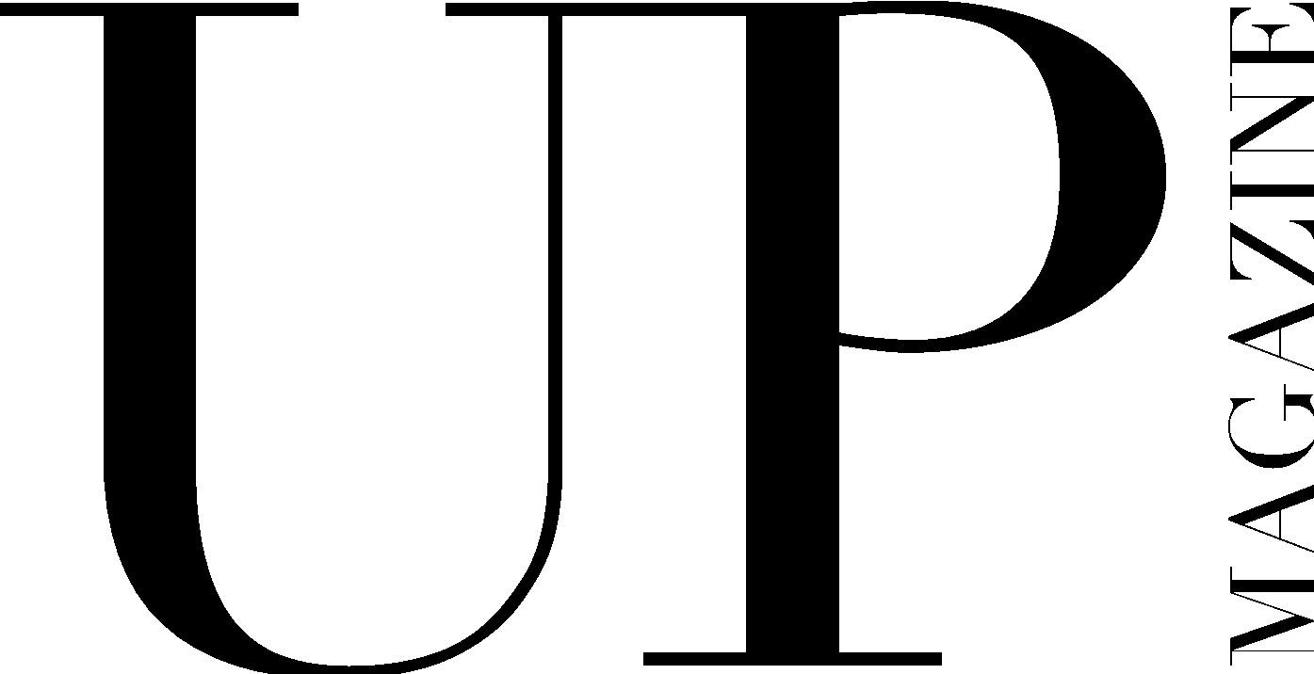

UP MAGAZINE REAPPLICATION

We are so happy that you have decided to be a part of UP Magazine again! This year’s Editor-in-Chief, Creative Director, Publisher, and Directors are so excited to rehire our amazing past staff and continue creating innovative, boundary-pushing content that reflects UP’s brand. Please fill out this application thoroughly and thoughtfully to ensure that we’re able to understand your unique skills, as well as your experiences as a staff member of UP.

*Please note, certain positions may require an interview as a part of the application process. If this applies to the position you are applying for, you will be contacted individually by the Director after submitting your application.

Name:
Email:
Year:
Phone:
Website (if applicable):
Major(s):
Minor(s):

Position(s) applying for:

Years of experience with UP & previous positions:

Current on-campus involvement:

What makes you the ideal candidate for this position?

What did you do well in your position last year?

What areas could you improve upon?

What do you think were the strengths and weaknesses of your team?

Please attach below (or in your email) examples of your work from last year:

