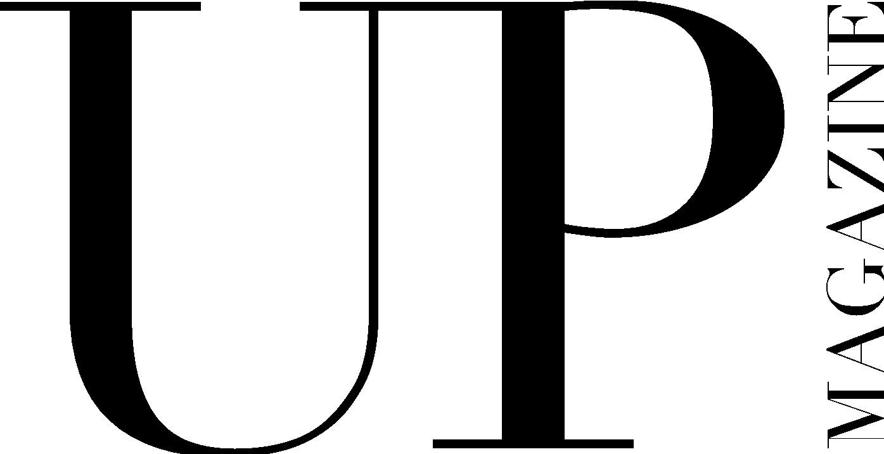

PRINT MAKEUP ARTIST / HAIRSTYLIST APPLICATION

UP Magazine is Miami University’s student-run fashion and lifestyle publication inspiring style and authenticity. UP Magazine is seeking talented, creative, committed, and driven students who are excited to be part of a collaborative and contemporary team.

The Print Makeup Artist / Hairstylist of UP Magazine is responsible for styling makeup / hair for at least one photoshoot that will be published in our fall and spring issues. The Print Makeup Artist / Hairstylist is responsible for working with a Print Stylist and a Print Photographer to execute the photoshoot. The Print Makeup Artist / Hairstylist will receive creative direction for all photoshoots from the Creative Director, Co-Directors of Fashion, and Director of Hair & Makeup.

Name:
Email:
Year:
Phone:
Instagram:
Major(s):
Minor(s):

Current on-campus involvement:

How much time can you commit to this position a week?

Related experience/portfolio:

Why do you want to be a part of UP Magazine? What would you add to our team?

Where do you find makeup/beauty inspiration?

Describe your makeup + beauty style and provide photos below:

Any additional information, questions, concerns, or comments:

