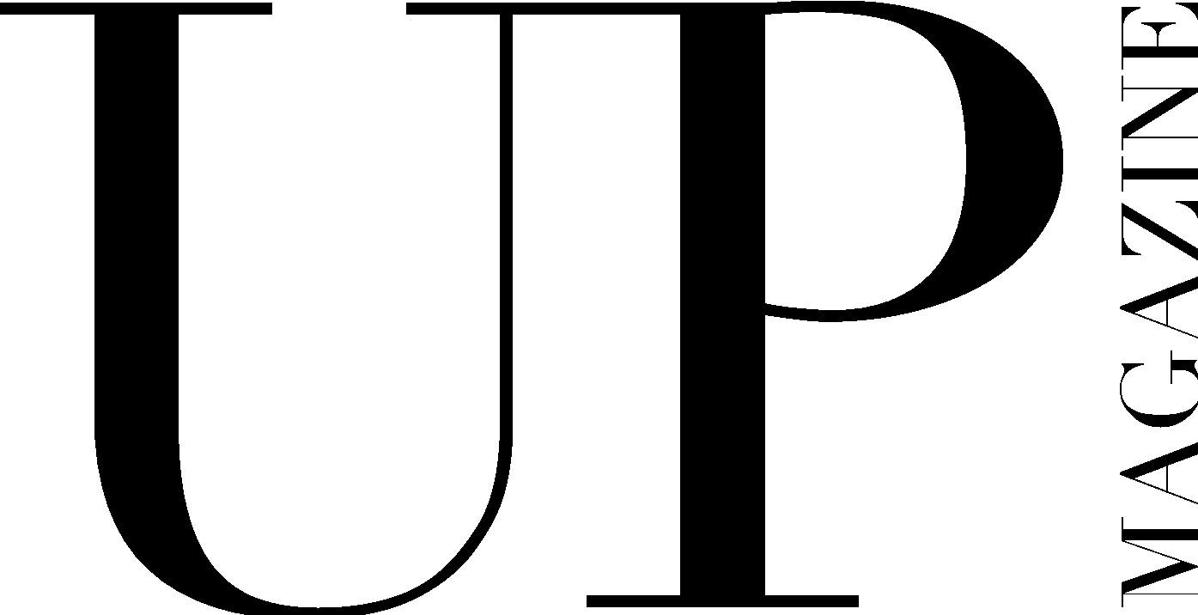

DIRECTOR OF FASHION APPLICATION

UP Magazine is Miami University’s student-run fashion and lifestyle magazine inspiring style and authenticity. UP Magazine is seeking talented, creative, committed, and driven student writers who are excited to be part of a collaborative and contemporary team.

The Director of Fashion of UP Magazine oversees the Styling Team consisting of Print Stylists, Makeup Artists, and Hair Stylists. The Director of Fashion is responsible for maintaining regular communication with the Styling Team, holding in person meetings, assigning the team to article and editorial photoshoots for each print issue, and supporting and guiding the Print Stylists, Makeup Artists, and Hair Stylists in their creative process. This position requires leadership, commitment, creativity, drive, and communication.

Name:
Email:
Year:
Phone:
Major(s):
Minor(s):

Current and/or previous experience with UP?

Related experience:

Current on-campus involvement:

If studying abroad or graduating early next year, please specify which semester:

What makes you the ideal candidate for this position?

Describe your personal style and provide photos of yourself showing it off below (or attached to the email):

If applicable, how has your experience working and styling for UP made you more qualified for the position?

How will you manage the Styling Team effectively?

Describe a stressful situation and how you handled it:

What stressful situations do you anticipate arising from this position and how will you handle those situations?

Where do you get styling inspiration?

Please share any additional information or work below:

