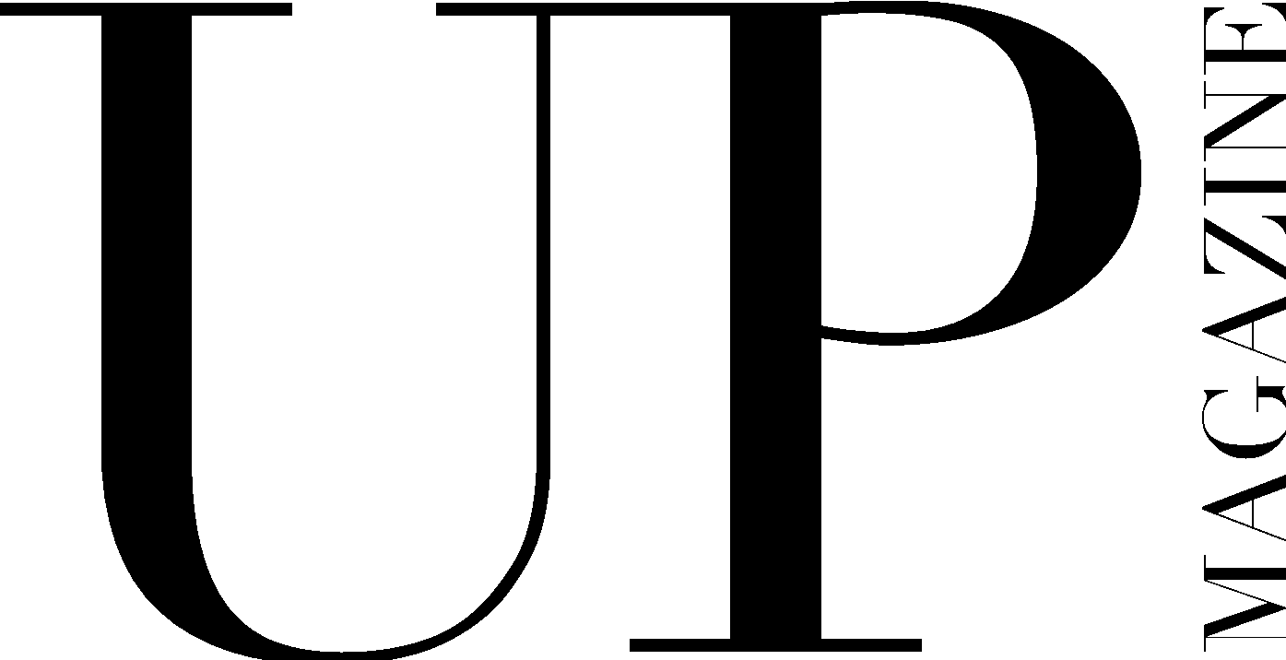

EDITOR-IN-CHIEF APPLICATION 2026-27

UP Magazine is Miami University’s student-run fashion and lifestyle publication inspiring style and authenticity. UP Magazine is seeking talented, creative, committed and driven students who are excited to be part of a collaborative and contemporary team.

The Editor-in-Chief of UP Magazine is responsible for all print and digital editorial content for the publication, as well as representing and communicating UP’s brand across all channels. Additionally, you will be responsible for conceptualizing the themes for two issues, choosing those that align with UP’s values and the mission of our brand: to inspire authenticity and creativity in our readers. The Editor-in-Chief oversees the Print Department, comprised of the Writing and Blogging Teams. You will work directly with the Publisher and Creative Director to ensure the success of the UP Brand and must be willing to be a team player and collaborate. This position requires strong communication skills, attention to detail and organization, as well as breakthrough creativity and a desire to take UP’s brand to new heights.

If you are interested in the Editor-in-Chief role, please submit this application and reach out to me, Charlotte Hudson, (847-274-2479), individually to discuss the position.

Name:
Email:
Year:
Phone:
LinkedIn:
Major(s):
Minor(s):

Current on-campus involvement:

Years of experience with UP:

Current and/or previous positions with UP:

Please list your commitments for the upcoming 26-27 school year.

Why do you feel that you are the best candidate for this position?

Do you have any past leadership or team management experience?

If applicable, how has your experience working and writing for UP made you more qualified for the position of Editor-in Chief?

How will you help UP maintain its brand across multiple platforms—magazine, web, Instagram, video, etc.?

How will you manage a staff of around 100 effectively and stay organized in keeping up with every team?

Describe an instance in which you were forced to use your editorial judgment and/or management/directorial skills to make a difficult decision, or react in an adverse situation:

How do you plan to make UP a better magazine, describing any goals or changes you plan to make?

CREATIVE EXERCISE
As Editor-in-Chief, you will be responsible for ideating each issue’s theme, definition and story ideas alongside the other UP 3 leaders and copy editors. As part of your application, we would like to see you stretch your creativity by developing a theme, its definition and three story ideas for the F/W 2026 issue.

Theme:

Theme Definition:

Three story ideas (include title + short blurb about the story):

Include any additional information about your vision for this theme (mood board, additional story ideas, editorial ideas, etc.):

